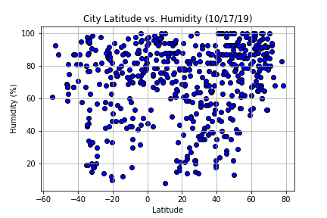

* 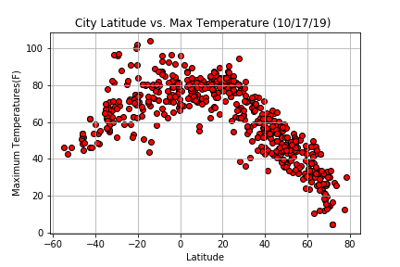It seems by this graph that the highest concentrations of humidity percentage are in those cities that are more distant from the equator, specially towards the north pole. I could be said that the closest to e north pole the highest the humidity will be.
* When observing the Latitude of the cities selected against the Maximum temperatures. It seems like the hotter cities are located closer to the equator line, and the colder cities are distributed with higher intensity towards the poles. According to the graph, the coldest cities of the cities analyzed are in the north pole.

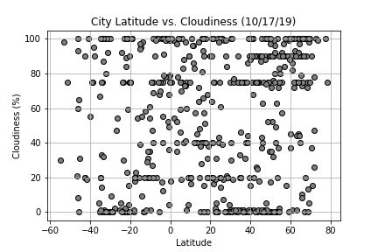

* The second quadrant of this graph seems to have the highest concentration of cities. Meaning that most of the data sampled, are within the latitude of 20 to 80 and a cloudiness percentage that ranges from 50 to 100.